|  |
| --- |
| ERASMUS+ PROGRAMME  Project Number: 574010-EPP-1-2016-1-JO-EPPKA2-CBHE-JP |
| **FOODQA - Fostering Academia-Industry Collaboration in Food Safety and Quality** |
| Report on Training Needs of the Food Industry in Jordan |
|  |
| August 13, 2017 |

**TABLE OF CONTENT**

1. **EXECUTIVE SUMMARY ………………………………………………………………………………………. 3**
2. **INTRODUCTION ……………………………………………………………………………………………….… 3**
3. **METHODOLOGY ………………………………………………………………………………………………… 5**
4. **KEY RESULTS …………………………………………………………………………………………………..... 5**

**4.1 The sector structure and profile ………………………………………………….………......……… 5**

**4.2 Training needs…………………………………….. …………….…………………… …………......……... 11**

1. **CONCLUSIONS …………………………………………………………………………………………………… 16**
2. **ANNEXES …………………………………………………………………………………………………………… 16**

**ANNEX I: Surveys Used…………………………………………………………………............…………………….**

1. **EXECUTIVE SUMMARY**

This report constitutes an analysis of the WP2 of the “FOODQA - Fostering Academia-Industry Collaboration in Food Safety and Quality”; an Erasmus+ project, which aimed at identifying the needs of the food industries in Jordan from Food Safety Centers that will be established at each university. A comprehensive survey was prepared by P&B-Portugal, then it was revised by the Training, Technical, and Quality Committees. The survey focused on identifying the importance of different training workshops and courses to the Food Industry in Jordan. Moreover, the surveys aimed at identifying the mode of the training these companies prefer the most. The survey was prepared using Google Templates and the link was sent to the food companies in Jordan. Forty-one companies completed the survey.

The survey showed that most of the companies are medium sized (in terms of workers, turn over, factory area) and work independently.

The training needs as indicated by the companies are all taken into consideration in the foodQA project. The priorities and the venue of training for the general worker is different than that or the spatialized personal. Such an issue should be takin into consideration.

1. **INTRODUCTION**

Food safety and the protection of end consumer health is of increasing concern to the public, non-governmental organization, professional associations, international trading partners and trade organization. The safety and confidence of consumers within the community and in the third countries are paramount importance. A food business operator is best place to devise a safe system for supplying food and ensuring that the food it supplies is safe, thus it should have primary legal responsibility for ensuring food safety. The introduction of preventive approaches such as the food safety management systems based on HACCP (Hazard Analysis and Critical Control Points) principles (ISO 22000:2005, IFS, BRC, Global Gap) are resulted in industry, and the food chain , taken greater responsibility for and control of food safety risks.

In Jordan Food safety is one of the top government priorities. Government has worked hard since decades to control and issue a set of legislations to guarantee the safety of food provided to citizens of Jordan. Ministry of health established the Jordan Food and Drug Administration in 2003. Jordan Food and Drug Administration (JFDA) worked as an independent public-sector institution that is the sole national competent authority for ensuring food safety and quality. The Jordan Food and Drug Administration was established to address scientific and global developments in food & drug control in Jordan. In the first decade, JFDA has embraced its role as a national competent authority for food and drug control, and has become the national Jordanian umbrella agency empowered to develop and implement unified standards, and lead cooperation and development programs through bilateral agreements with many national, regional and international bodies. The JFDA is entitled to exercise all legal actions that are deemed necessary to achieve its goals through setting & implementing legislations, monitoring & surveillance, and raising the public awareness.

The FoodQA is an EU funded project through Erasmus+ Project, that concentrates on strengthening and enhancing the role of universities (academia) and industry in food sector. The creation of interface centers between the industry and academia is intended to support the HEI and structure the interfaces between Academia and Industry; making available to the food sector technical and scientific services that can contribute to the development of the industry and to strengthen its competitiveness in the direction of a future collaboration with the European Union in particularly in the area of food safety and quality. The successful implementation of this project depends mainly on training Jordanian staff and exposing them to the European experience in establishing and managing Food safety and food quality. Thus, the EU cooperation is crucial for the successful implementation of this project. Our EU partners in the academia, incubators, R&D, and private sectors have proven record of accomplishment in this field. Partners from the EU academia will provide their experience in implementing similar project in Jordan. Training will be conducted by EU partners in EU countries and in Jordan. The EU partners have complementary experiences in the field of food and food quality. Agricultural University of Athens (AUA) and University of Teramo (UniTE) are the EU partners with the competencies in food safety and food safety and quality management system, SPLIT and P&B and are the EU partner more actively involved with industry.

1. **METHODOLOGY**

To identify the skills and competencies needed by the market, a comprehensive survey has been developed carefully. A Google Template was used. The link of the survey was sent to the target group, which was the food industry in Jordan. Annex I shows the survey that was used.

The participant in this survey are the are food industry companies that are working in Jordan. 41 responses were received electronically through google forms, the link to the form was distributed through emails. all the responses from the target population were considered.

Some of the participants skip one or more question so Individual responses on sub-sections may be less than the total number of respondent.

The Survey can be divided into two main parts; the first is concerning the company itself and the second part is concerning the priorities and importance of the different training subject. In the last question, the respondents were asked to provide their comments and recommendations that you might be considered important to FoodQA project development.

1. **KEY RESULTS**
   1. The sector structure and profile

Q1: How much is your plant area?

This question is important to understand the area that the QA personal needs to control and supervise. The answers represent the total area of the plant rather than the area of the clean zones inside the plants.

The responses were divided into 4 categories, Small: with area, less than 1000m2, Medium; with area more than 1,000m2 and less than 5,000m2, Big; with area more than 5,000m2 and less than 10,000, and Very big with area more than 10,000m2.

The result indicates that about half of the participating companies have a medium area. The following figure shows the percentage of the responses of each category.

Q2: When was your company established?

The responses to this question were grouped into the decades. The results show that most of the participating companies were established during the last two decades. This can be attributed to two reasons; the first is that a lot of new companies were established in the last two decades as a response of the growing population and the second is that the new companies tend to have more interest in the QA systems. The following figure shows the grouped responses of the question.

Q3: Type of the company

The aim of this question is to understand how much of the companies surveyed are administrated independently or part of national or multinational groups.

The results indicate that most of the respondents are independent companies; the following figure shows the percentage of the responses;

Q4: What are your sectors of activities?

This question aims at identifying the food sectors the participating companies are involved in. The answers to this question can help in prioritizing the different workshops and training these companies need. The figure below summarized the answers to this question.

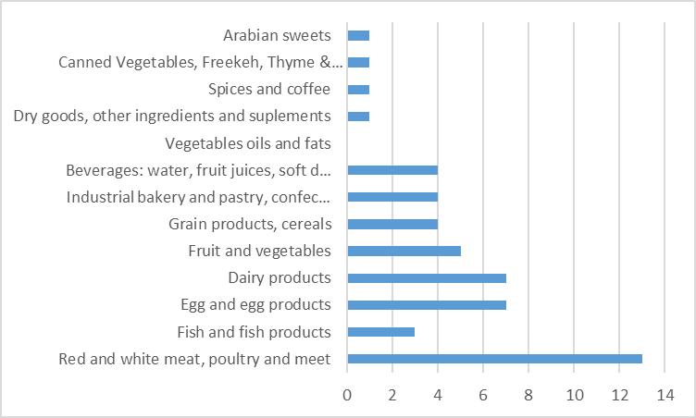

Q5: Where is your company is located; City and town.

This question explores the geographical distribution of the companies involved and their spread through Jordanian geography. The importance of this question is to ensure the geographical diversity of the research sample, in addition to determining the geographical location that will be worked upon in preparing the training materials. The response shows more than half of the companies are located within Amman Governate and Zarqa or the central governorates and then the northern governorates and then the governorates of the south. The responses are detailed in the following figure.

Q6: How much is your company turnover in JD:

The results of this question correspond to the results of the first question. Companies can also be divided according to the size of their sales and hence the size of the work is assigned to the control teams and the quality control. The following figure reports the answers of the respondents. It is noted that 40% of respondents did not answer this question.

Q6: Where is your export regions:

The markets of exports determine the needed quality system and the impose special requirements on food producers, another important issue in this contest is that not having the right certificate may reduce the potential of the markets of exports. Most of the companies surveyed export market are limited to the middle east. The following figure reports the answers of the respondents.

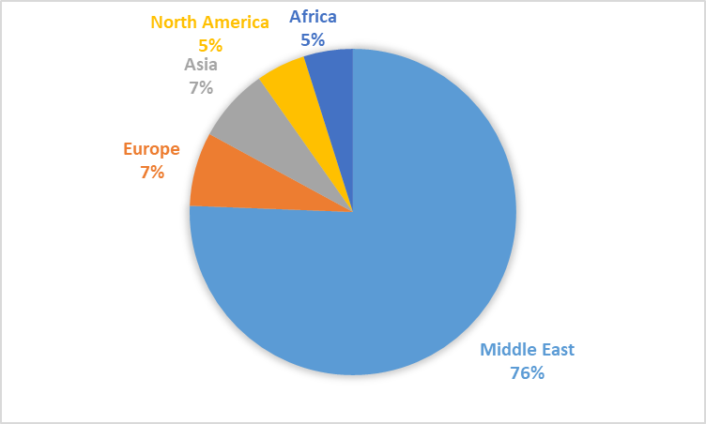

Q7: who is your customer?

The type of customer also determines the needed quality system and the impose special requirements on food producers and failing to meet the customer requirements means that the customer is lost. The outcome of this question determine may determine the priorities of the companies regarding the quality system needed to be imposed. The following figure shows that clear majority of the companies surveyed do not sell their products to the finial customer directly rather than sell it directly to the customer.

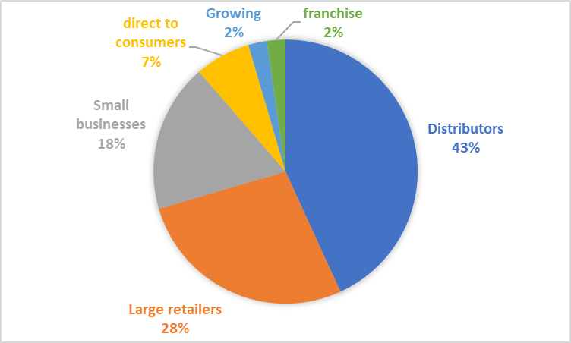

Q8: What is the certifications held by your company?

The following figure shows the percentage of the companies by its food quality certificates that is applied by the company, the result shows that 56% of the surveyed companies apply one or more quality system, about 20% of the companies apply more than one quality system. The most quality system applied is ISO9001 then ISO 22000 then HACCP. Please note that the companies how did not answer this question was considered with the companies that do not apply any quality system.

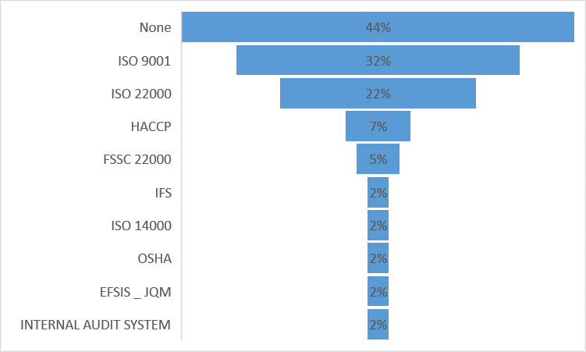

Q9: How much is the total number of workers in your company?

This question shows how much the quality system is important in the company, if the number of workers is big then then the company should apply a system that assure the quality of their products. About half of the surveyed companies are big in terms of the number of worker.

Q10: How much is the number of the qualified staff who hold higher education degree?

This shows the total number of staff that should be involved either directly or indirectly in the quality system. The result shows that that 30% of surveyed companies has more than 30 qualified personal and 23% has more 15 qualified personal.

Q11: How much is the number of the qualified staff in food industry?

The following figure shows the distribution of the companies by the number of the qualified staff in food industry, this show the number of the staff how is directly involved in the quality system application and supervision.

**4.2 Training Needs Assessment**

This part shows the self-assessment by the stockholders of their training needs and priorities.

Q12: Perception of the level of qualification of the general workers per subject.

Most of the companies surveyed stated that the Perception of training general worker are average or blew. 30% stated that it is high or very high.

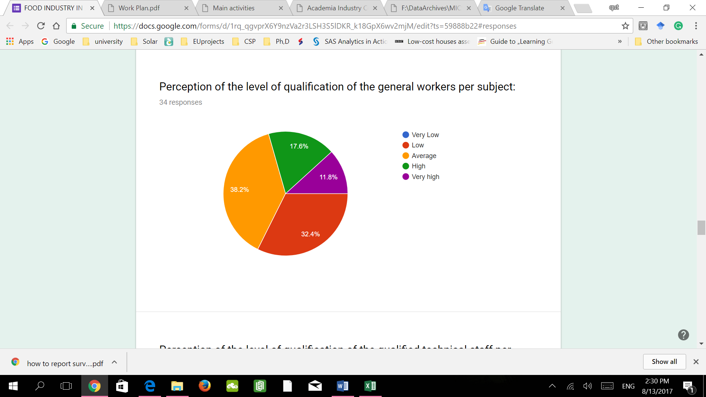

Q13: Perception of the level of qualification of the qualified technical staff per subject.

This question is related to the previous one and it shows that about 2/3 of the surveyed companies think that perception of the level of qualification of the qualified technical staff are on average or below.

Q14: Training needs of general worker per subject:

The half of surveyed companies stated that there is high or very high of need of training for the general worker by subject. And about one third of them stated that it is of average importance.

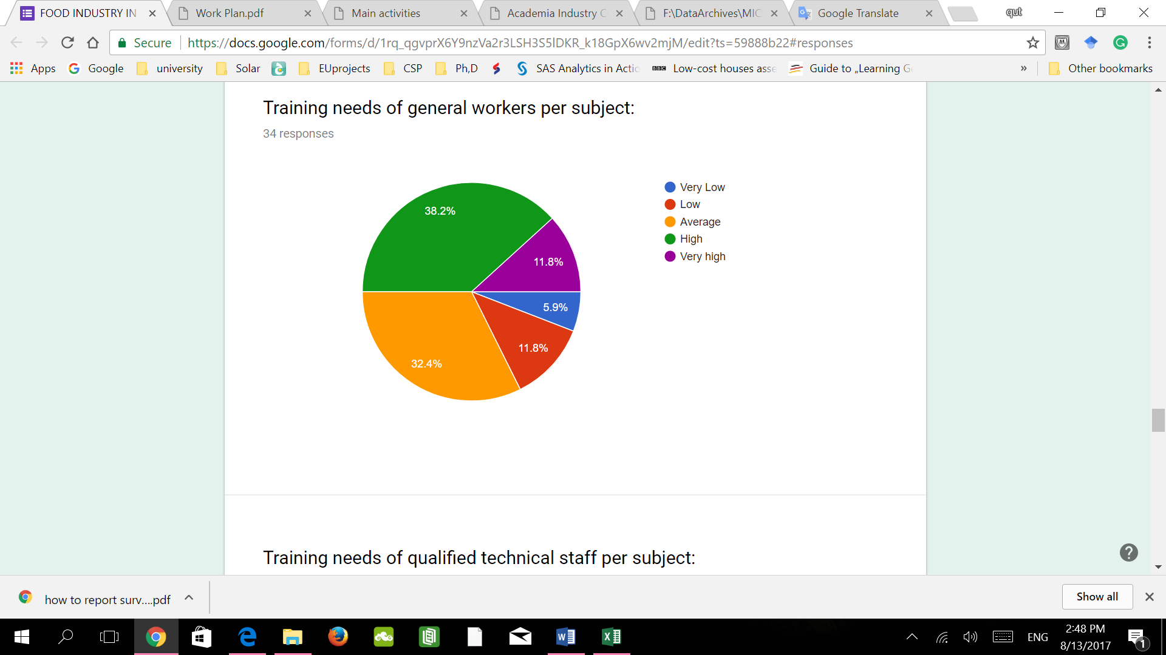

Q15: Training needs of qualified technical staff per subject:

The answers show that there is higher need of training of qualified staff rather than the general worker (results from Q14) that is because general workers can be trained by their team leaders and supervisors, so, focusing on leaders and higher staff levels training would be more efficient.

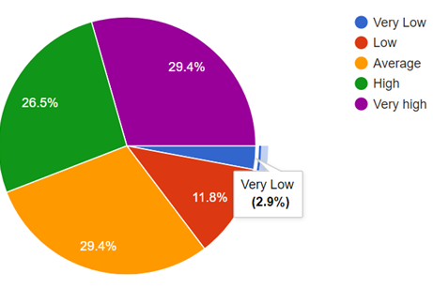

Q16: Importance of the subjects in the training of the general workers:

This question shows that the general workers training should not be general and there are some subjects that is more important than the others. More than half of the respondents agrees with this.

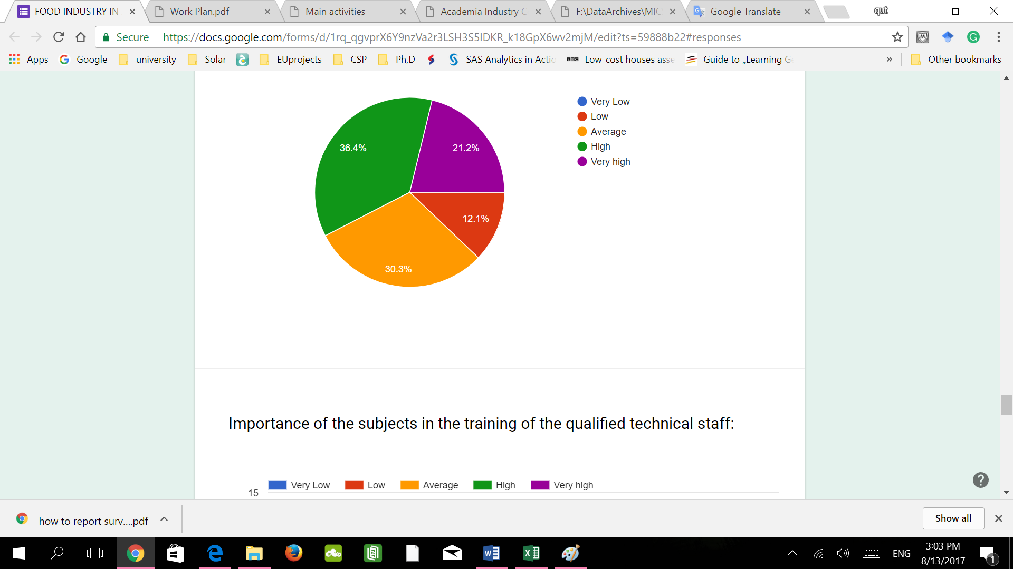

Q17: Importance of the subjects in the training of the qualified technical staff:

The results of this question represent the priorities and relative importance of the different subjects as Identified by the surveyed companies. The companies stated that all the subject have above average importance; which shows that the subjects identified by the FoodQA Project are relevant and accurate.

Q18: What type of training do you think is more recommendable to the general workers in the following subjects:

Most of the companies wonted their general worker to be trained in house and about 56% of them wonted their general workers to be trained on the job. Only 9% wont E-learning for their general worker

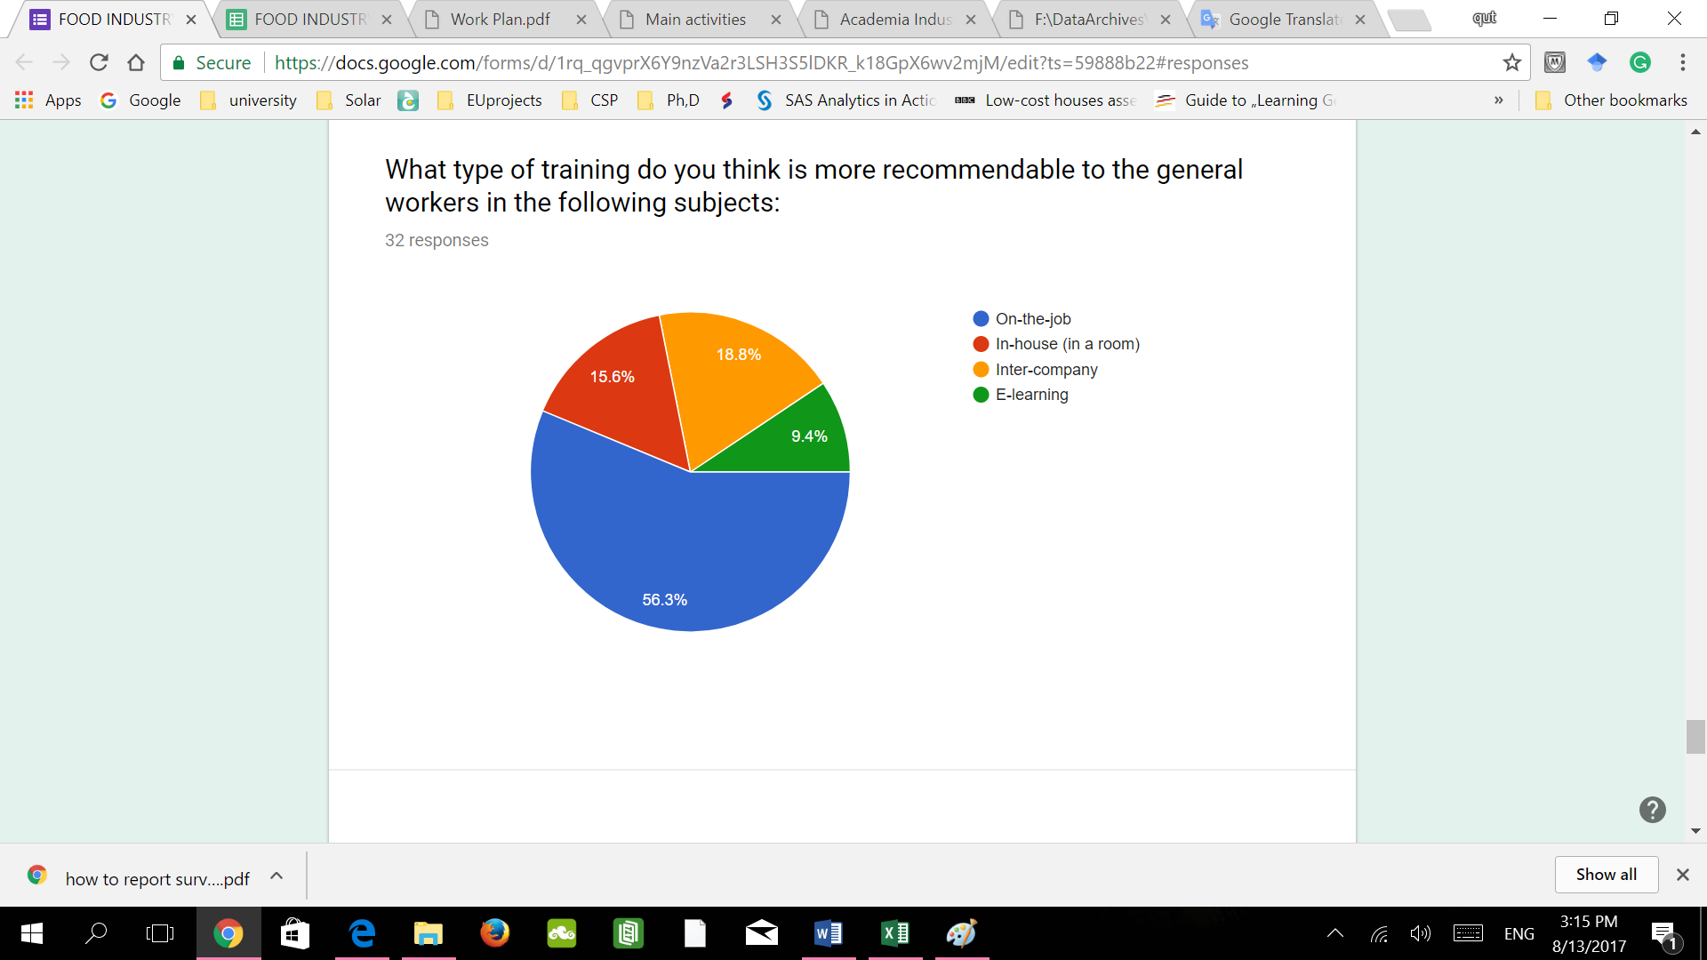

Q19: What type of training do you think is more recommendable to the qualified technical staff in the following subjects:

In this question, the respondents chose the venue that the think it most suitable for the deferent subjects. The following figure shows the accumulative percentage of the answers. There is no definite venue for all the subject, rather than each subject has its suitable venue. For example, the respondents wont their personal to be trained on the hygiene related subjects on the Job, while the administrative and more complicated subjects they chose Intra-company or E-learning.

The accumulated result shows that although Intra-company training is the most preferred type, E-learning have high acceptance among respondents.

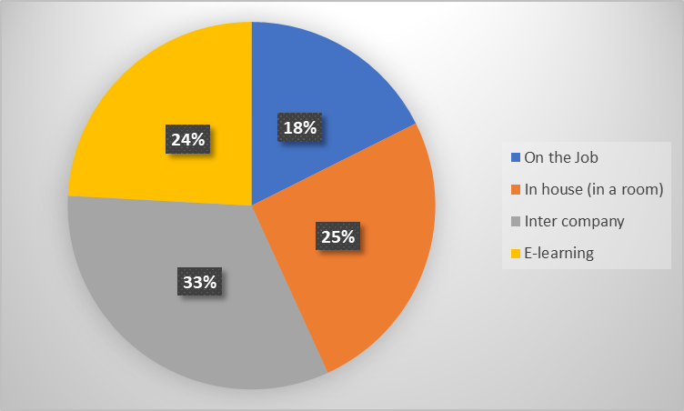

1. Conclusion:

The following figure shows the average importance of the subjects on a scale of 1 to 5 estimated from the analysis of survey result, it shows that the basic subjects like pest control and hygiene have the highest priorities. Then the hazard analysis related subjects. The basic competencies have the highest important factor because it is important for all worker not only by qualified